Preparation of Articles for IEEE TRANSACTIONS and JOURNALS(2022)

First A. Author, *Fellow, IEEE*, Second B. Author, and Third C. Author Jr., *Member, IEEE*

[[1]](#footnote-1)

***Abstract*—This document provides a guide for preparing articles for IEEE Transactions, Journals, and Letters*.* Use this document as a template if you are using Microsoft *Word*. Otherwise, use this as an instruction set. The electronic file of your article will be formatted further at IEEE. Titles should be written in uppercase and lowercase letters, not all uppercase. Avoid writing long formulas with subscripts in the title; short formulas that identify the elements are fine (e.g., "Nd–Fe–B"). Do not write “(Invited)” in the title. Full names of authors are preferred in the author field but are not required. Put a space between authors’ initials. ORCIDs can be provided here as well. In the title, all variables should appear lightface italic; numbers and units will remain bold. Abstracts must be a single paragraph. In order for an Abstract to be effective when displayed in IEEE *Xplore* as well as through indexing services such as Compendex, INSPEC, Medline, ProQuest, and Web of Science, it must be an accurate, stand-alone reflection of the contents of the article. They shall not contain displayed mathematical equations, numbered reference citations, nor footnotes. They should include three or four different keywords or phrases, as this will help readers to find it. It is important to avoid over-repetition of such phrases as this can result in a page being rejected by search engines. Ensure that your abstract reads well and is grammatically correct.**

***Index Terms*—Enter keywords or phrases in alphabetical order, separated by commas. Using the IEEE Thesaurus can help you find the best standardized keywords to fit your article. Use the thesaurus access request form for free access to the IEEE Thesaurus**  [https://www.ieee.org/publications/services/thesaurus.html](https://www.ieee.org/publications/services/thesaurus.html" \t "_blank).

# I. INTRODUCTION

T

HIS document is a template for Microsoft *Word*. If you would prefer to use LaTeX, download IEEE’s LaTeX style and sample files from [https://template-selector.ieee.org/secure/templateSelector/publicationType.](https://journals.ieeeauthorcenter.ieee.org/create-your-ieee-journal-article/authoring-tools-and-templates/tools-for-ieee-authors/ieee-article-templates/) You can also use the Overleaf editor at [https://www.overleaf.com/blog/278-how-to-use-overleaf-with-ieee-collabratec-your-quick-guide-to-getting-started#.Vp6tpPkrKM9](https://www.overleaf.com/blog/278-how-to-use-overleaf-with-ieee-collabratec-your-quick-guide-to-getting-started%23.Vp6tpPkrKM9).

This template is a guide to formatting; your proof and final published version may vary in layout and length to conform to IEEE policy and style. Page count is an estimate; the length of your submitted article in the template may not be the same as when the formal proof is created by IEEE

The *IEEE Editorial Style Manual for Authors* is available at <https://journals.ieeeauthorcenter.ieee.org/create-your-ieee-journal-article/create-the-text-of-your-article/ieee-editorial-style-manual/>. This contains a formal set of editorial guidelines for IEEE Transactions, Journals, and Letters, including:

* punctuation;
* capitalization;
* abbreviations;
* section headings;
* numbers, equations;
* footnotes;
* biographies;
* some common mistakes;
* units of measurement.

Communicate your work clearly. If you are not fully proficient in English, consider using an English language editing service before submitting your article. An expert editing service can help you refine the use of English in your article, so you can communicate your work more effectively.

The use of an editing service is paid for by the author. It does not guarantee acceptance in an IEEE publication. For more information, visit the IEEE Author Center at <https://journals.ieeeauthorcenter.ieee.org/create-your-ieee-journal-article/create-the-text-of-your-article/structure-your-article/#editing-service>.

# II. The Power Gain Distribution

## A. System Model

The illustration of the satellite distributed beamforming scenario is illustrated in Fig.1. The overlapped region of multiple satellites is utilized to provide service for randomly distributed users on the ground. This shared area receives high power gains, thus the communication link budget for the users is enhanced.

Fig1

Fig2 is the system model, where *N* ground users randomly distributed in the  plane, within the target area where beams overlapped. *M* satellites are available to be chosen from a set of available satellites all in the  plane. Each satellite has a track and is considered available within the visible area. The distance of is the distance between satellite *m* and user *n*..

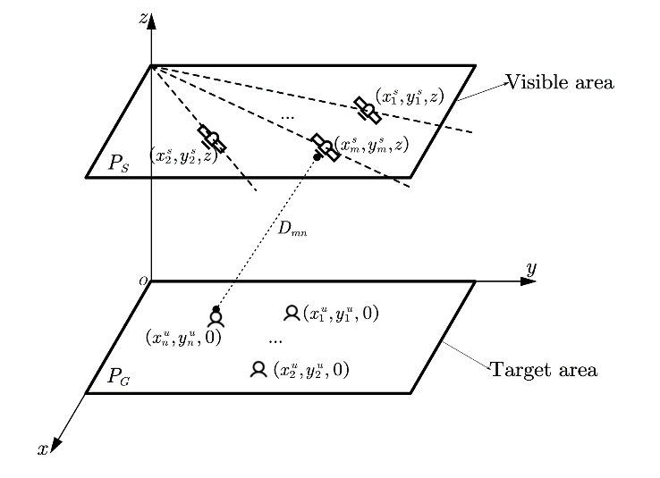

Fig2 is a simplified model of the earth and satellite orbit. This approximation is illustrated in Fig3.. The original model is illustrated in Fig 3.,andare calculated according to the parameters in Table Ⅰ. They are small enough to be ignored, thus the two arc faces can be approximated into planes.

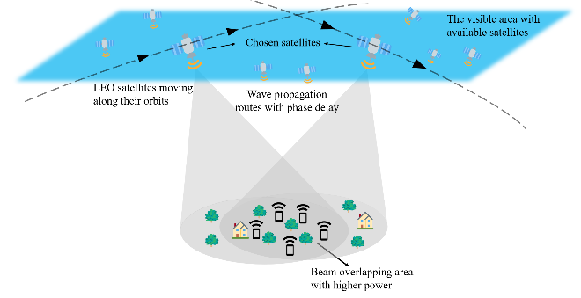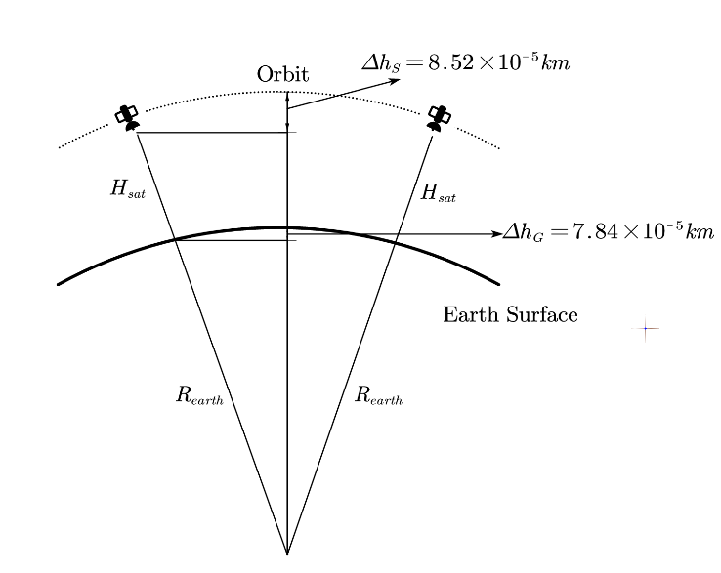

## B. Changing the Power Distribution

It is analyzed in [5] that when the beam coverage of multiple satellites overlaps, the transmitting EM waves constructively interfere with each other. Considering the power gain distribution on the ground, this interference leads to fringes of spot beams in terms of satellite number. Fig2 is an example of this distribution.

The principle behind this phenomenon is that the propagation path between satellites and different locations on the ground varies, causing various EM wave phases. When the phases are aligned, the highest power gains are achieved, while when waves are out of phase, they form the lowest power gain. This resembles the physical phenomenon of the famous double-slit experiment (when there are 2 satellites). The wave path difference forms fringes or spot beams.

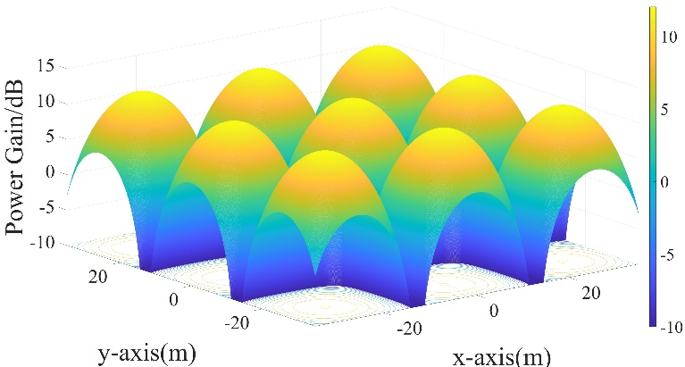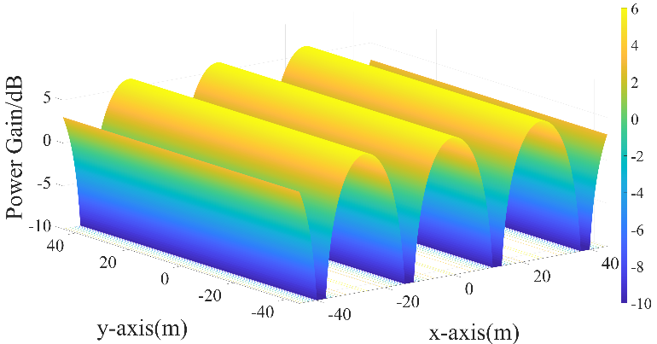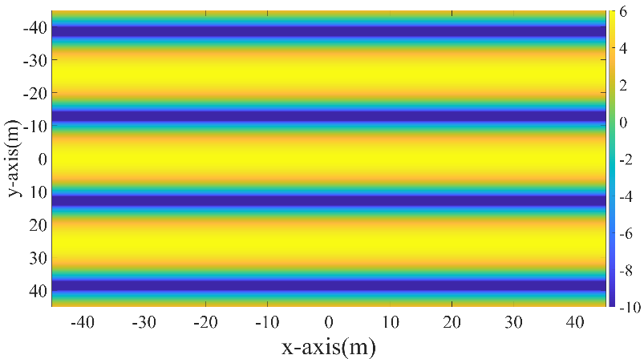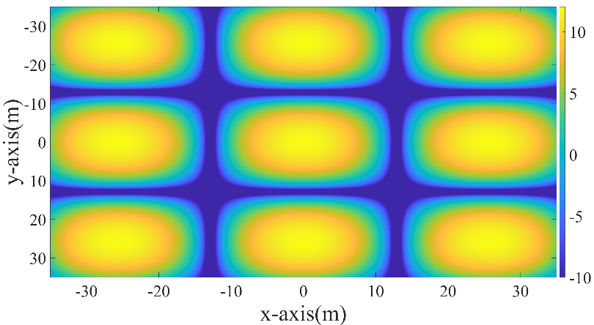

The phase delay caused by the propagation route can be denoted as:

，

where  is the distance between a satellite *m* and a ground user *n*.  denotes the wavelength of the transmitting EM wave.

For simplicity, we only consider the E-field. The E-wave transmitted by satellite *m* can be derived as:



where *A* is the amplitude and is the initial phase of the wave transmitted by the satellite.

Thus the E-wave arriving at ground node *n* becomes:



The polarization method can affect the superposition of EM-wave from different satellites. In [5], linear polarization is analyzed and proves that the difference of polarization directions can lead to a gain loss when the satellites are not moving in parallel tracks. In this article, we consider circular polarization instead of linear polarization for two reasons: Firstly, it is more common in satellite communications. Secondly, even when satellite tracks intersect with each other, circular polarization does not necessarily lead to a power gain loss. The illustration is shown in Fig3.  is the track angle and is the rotation angle of circularly polarized EM waves transmitted by the satellites. When



The waves of two satellites are considered aligned. This means the effect of satellite tracks can be compensated by adjustment of the satellite transmit phase.

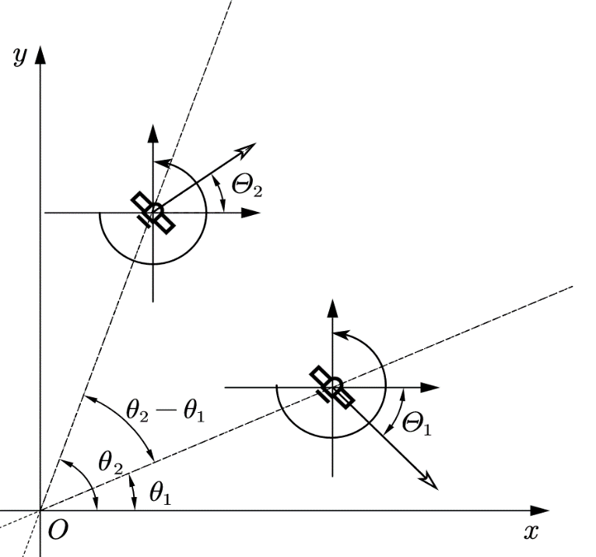

Fig3

By including the track angle effect in the adjustment of , the superposition signal of E-waves from all satellites for node *n* can be denoted as:



The power of the signal can be calculated as:



The maximum power gain is achieved when all waves are constructively added, where the phase components satisfy:



Substituting , becomes:



According to , the power gain distribution varies as the path length  and the initial phase changes. In other words, there is a certain ground power gain figure for a set of and.

## B. From MISO to MIMO

As shown in Fig2, along with the bright region of the highest power gain, there are dark regions where waves destructively interfere and have the lowest gain. When the serving target is located in the dark area, the link budget is severely interrupted. The dark region of power gain on the ground is unavoidable due to the physical principle of EM-wave. However, we still want to utilize this periodic distribution to serve multiple targets. In brief, to cover each target with a beam of the highest power gain.

To achieve this, the power distribution should be controlled to force the bright region to cover the targets, by adjusting the wave pathand initial phase. The initial transmit phase is controlled with phased arrays on satellites. The transmit wave phase can be controlled by conducting the same phase shift to every array element. On the other hand, can be modified by selecting satellites.



## C. Multiple Target Distributed Beamforming

To provide the ground users with the overall highest power gain, the most suitable satellites and their according transmit wave phases need to be optimized.

Suppose each satellite is equipped with a phased array of *Q* elements. Rewrite, The array synthesized signal on satellite *m* can be derived as:



where  andare the element gain and phase shift, respectively. The latter only controls the beam-pointing direction and is settled during our distributed beamforming process. is also settled to be the largest available gain because it does not affect the distribution of ground power gain. Only  is optimized. We define a set of available satellites *S*, each having its pre-settled track, and select *M* satellites. Locations of the chosen satellites are used to calculate the propagation route between satellite and ground nodes. therefore becomes:



To judge whether the ground nodes receive ideal power gain, we define two functions. The first is the normalized average power defined as:



where, and

The second is a normalized variation limitation, which is defined as:



where is defined as:



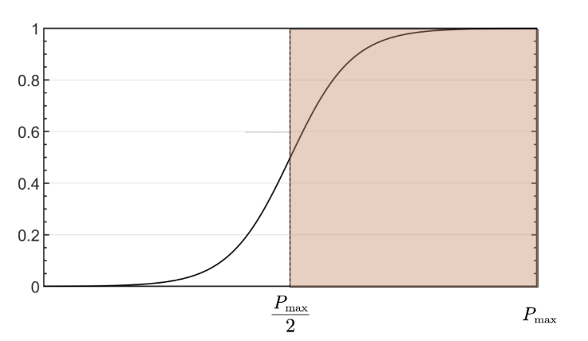

Fig shows the distribution of, as approaches, the value approaches the maximum 1.

The weighted objective function is thus defined as:



where is the locations of *M* satellites, which is chosen from a set of available satellites , is the according satellite transmit phase, and is a weight factor. The first term is the average power gain, which is the mean of power gains at the locations of all nodes. The second term is a fairness term, which ensures all nodes receive similar power gains. *g* is set to be negative for minimization. This function is defined as the overall judgment of the power condition of the ground target area.

The complete problem is formulated as follows:



s.t 



We choose Genetic Algorithm to solve the problem for the following reasons:

1. The phase varies rapidly in a periodical manner as the satellite and node location changes, which leads to many local solutions. GA searches for a global solution and contains a mutation process which avoid local solutions.
2. The satellite location is chosen from a set of available locations, making the function discrete. A search algorithm avoids calculating gratitude, which is better for this problem.
3. The solution space has a low dimension. GA algorithm becomes easy to design and can converge quickly.

In GA, the value of phases of satellites are directly optimized. However, the selection of satellites need to be transferred into optimization of a value. Suppose containselements, thus there areways of satellites selection. The satellite coordinate set  is mapped into a label set  in which each available satellite is labeled. The selections are labeled, and the label of selection, defined as  are optimized. All the selections form matrix . The *th* row of

Some predefined parameters of GA include: the max generations, the selection rate , the mutation rate .and the population size 

The process of GA is as Algorithm Ⅰ:

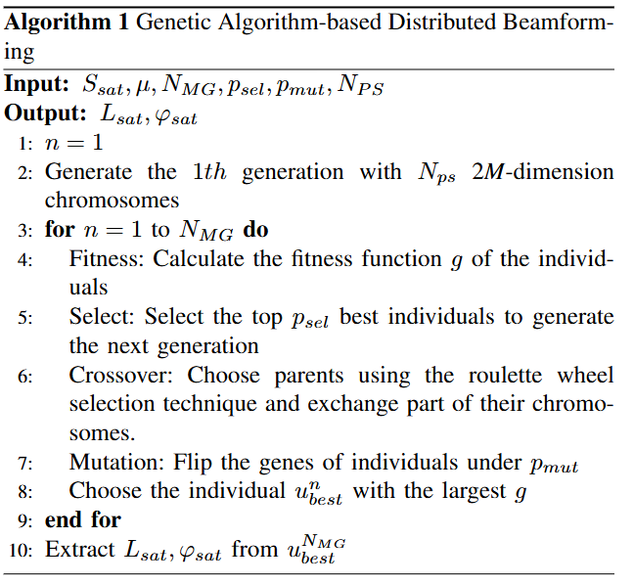

1. Design Genotype: The genotype of a chromosome can be derived as:
2. Generating Population: Generate *I* individuals with random chromosomes.
3. Fitness Function: Use () as the fitness function to judge every individual.
4. Selection: The top 50% of individuals with higher fitness are selected to generate the next generation.
5. Crossover: Two parenting individuals exchange part of their chromosomes to generate the next generation.
6. Mutation: The gene of individuals flipped according to a given probability.
7. Adds the new individuals into the population, if the ending condition is satisfied, the calculation completes, else returns to (2).

## D. The Satellite Motion

The algorithm in *C* gets the best satellites and the according phases of the satellites. However, the satellite is moving, thus the phases may be unsuitable for future satellite locations. This means ground nodes can only receive ideal power gain temporarily. An algorithm that can adaptively update the phases on satellites according to their motion is required to provide constant services for ground nodes.

Since the track is known and the satellite is moving at a constant speed, we assume that the location of satellite *m* at the *nth* time slot is known, denoted as:



where is the initial satellite location, *T* is the update interval, is the track angle.

The weight function also becomes time-varying, denoted as:

The problem is to solve at each time slot with the known satellite locations. The proposed GA-based algorithm is no longer useful, because after the calculation, satellites move to other positions and the calculated phases are not suitable for new satellite locations. A new algorithm for moving satellites is necessary.

One idea is to apply adaptive beamforming algorithms, for example, LMS or RLS to adjust phases. However, the satellite velocity is too large for a tracking algorithm to converge. As a result, for each time slot, the according phase has to be recalculated. The calculation time and update interval have to be short enough to make the phase constantly suitable for ground nodes.

Therefore, the new problem for time slot *n* becomes:



s.t 

The solution space has an even lower dimension (M phases only), which saves calculation time. Also, is a normalization of the phase, which can be conduct before or after solving the optimization problem. Thus this optimization can be considered unconstrained.

To get the solution, we introduce a unconstrained minimization method based on trust region and Quasi-Newton method. The advantages include:

1. An approximation of the objective function helps accelerate the calculation.
2. The phase of the former time slot can be utilized.

The process is as follows:

Define *G* as the trust region for and *s* as the trial step. We search for a better solution that gets a smaller within *G*, i.e.



Define a quadratic approximation of as:



which is the second-order Taylor approximation of at point *x*. *H* is the Hessian matrix.

The problem becomes:



s.t 

where *D* is a diagonal scaling matrix and is a positive scalar. A quick solution. A quick solution of this problem is achieved by considering a 2-dimension subspace, spanned by and [6], which satisfies:





The solution is given by:



By iteratively update *x* and, the solution of is achieved. The process is shown in Algorithm Ⅱ.

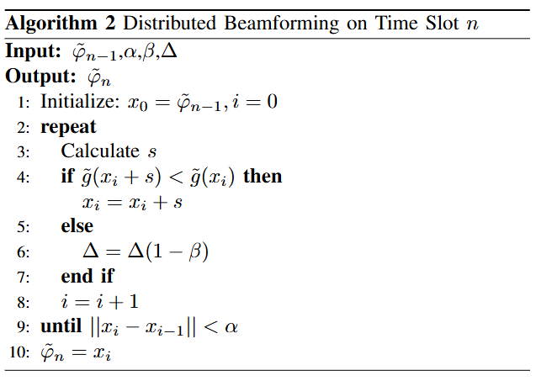

The process is repeated as satellites move. By setting a short update interval *T*, this quick algorithm can get phases that are always suitable for changing satellite locations, providing consistent services for ground nodes.

## E. Satellite Re-selection

At one point, certain satellites may get out of range, becoming unavailable for ground nodes. The available time is shown in Table ⅠI. In that case, *M* satellites have to be re-chosen from a new set of available satellites and the related phases on satellites have to recalculated according to the algorithm presented in *C*. This leads to a loop, which is shown in Algorithm Ⅲ. In brief, suitable satellites are chosen from all available satellites and phases are calculated. Then the algorithm in *D* updates the phases for the chosen satellites to keep the power gain constantly ideal for ground nodes. Once any satellite moves out of available range, we return to the beginning and the above process repeats.

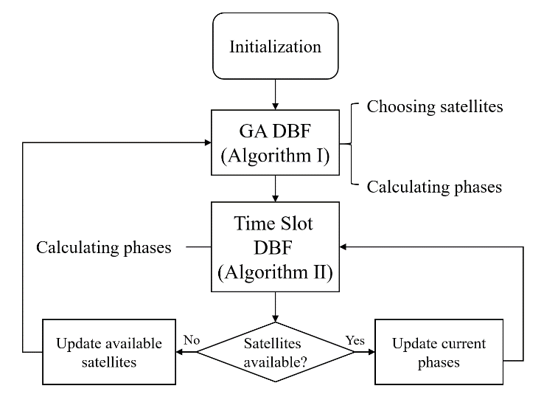

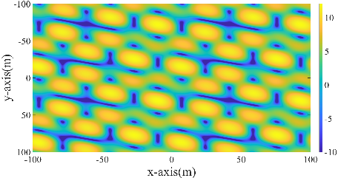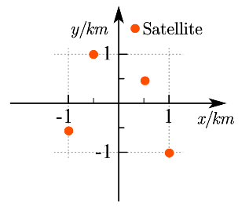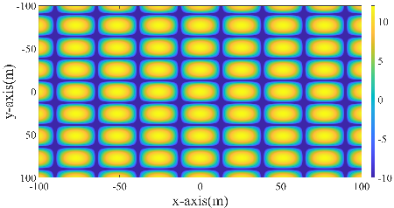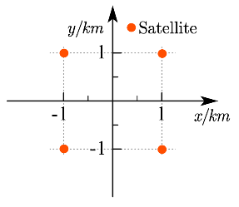

# III. Simulations

Simulations are conducted to verify the effectiveness of the proposed algorithm. The settings are listed in Table Ⅰ.

TABLE I

Parameters

|  |  |
| --- | --- |
| **Parameters** | **Values** |
| Earth radius | 6371km[4] |
| Satellite orbit height | 600km |
| Length of the target area(square) | 1km |
| Length of the visible area(square) | 2km |
| Satellite speed | 7.8km/s[1] |
| Satellite available time | 3s[2] |
| Number of available satellites | 10 |
| Number of ground targets | 7 |
| Operating frequency | 3.5GHz[3] |

## A. Factors affecting Power Distribution

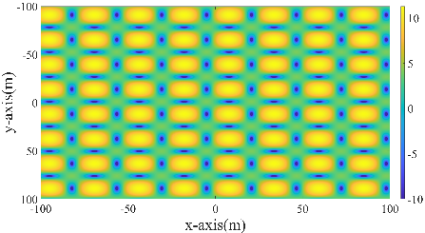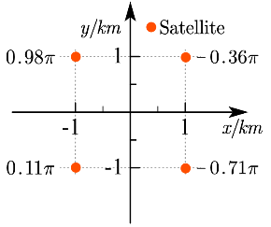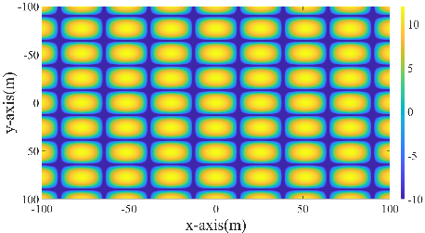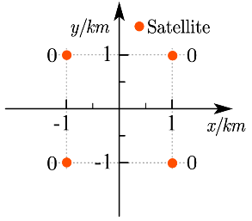

In this section, we examine how satellite locations and the transmit phase affect the power distribution on the ground. The satellite number is 4.

First, the influence of satellite locations is examined. The transmit phases are set to be 0 on all satellites. Two sets of satellite locations and the according distribution are shown in fig.

Then we show the influence of transmit phases. The satellites are located as fig1.a. The phases in (a) are all 0. In (b) they randomly distribute within.

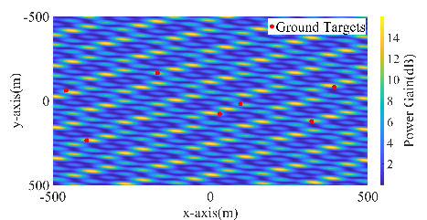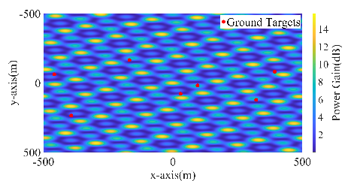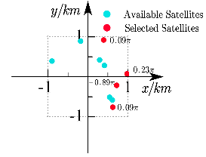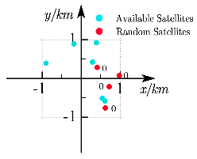

It can be seen that both satellite locations and transmit phases largely affect power distribution, thus making it feasible to adjust power distribution according to the distribution of targets on the ground.

## B. GA-based Distributed Beamforming

The GA algorithm selects the most suitable satellite and their according transmit phase. 20 experiments are conducted. For each experiment, we set 10 satellites within the visible area and 7 ground target on the ground, both randomly.

` The power received by ground targets are also shown. The results demonstrate that our algorithm can greatly improve the receiving power of ground targets.

The statistic results of 20 experiments are shown in . It shows that our algorithm has ideal performance in most cases, no matter the distribution of satellites and ground targets.

We pick one experiment (Label 6) and show detailed results. To better illustrate the effect of our algorithm, the power gain figures on the ground are shown((a) and (b)). The satellite selection and according phase are also presented.((c) and (d)). (a) and (b) are the original case with random satellite selection and no phase adjustment. (c) and (d) are the optimized case. The comparison between the ground power gain before and after optimization demonstrate the effectiveness of Algorithm Ⅰ. The score of power condition for ground targets, defined as, raised from 0.13 to 0.71(maximum 1).

## C. Distributed Beamforming with moving satellites

We further demonstrate the effectiveness of the proposed algorithm for moving satellites. Since Algorithm Ⅱ is part of the loop of satellite re-selection, we conduct 5 loops of satellite re-selection process to validate both Algorithm Ⅱ and the effectiveness of satellite re-selection design.

The calculation time of the proposed algorithm is crucial because of high satellite velocity.

# IV. Guidelines for Graphics Preparation and Submission

## A. Types of Graphics

The following list outlines the different types of graphics published in IEEE journals. They are categorized based on their construction, and use of color / shades of gray:

* 1. **Color/Grayscale Figures**  
     Figures that are meant to appear in color, or shades of black/gray. Such figures may include photographs,   
     illustrations, multicolor graphs, and flowcharts.
  2. **Line Art Figures**  
     Figures that are composed of only black lines and shapes. These figures should have no shades or half-tones of gray, only black and white.
  3. **Tables**  
     Data charts which are typically black and white, but sometimes include color.

## B. Multipart Figures

These are figures compiled of more than one sub-figure presented side-by-side or stacked. If a multipart figure is made up of multiple figure types (one part is line art, and another is grayscale or color), the figure should meet the stricter guidelines.

## C. File Formats for Graphics

Format and save your graphics using a suitable graphics processing program that will allow you to create the images as PostScript (PS), Encapsulated PostScript (.EPS), Tagged Image File Format (.TIFF), Portable Document Format (.PDF), JPEG, or Portable Network Graphics (.PNG). These programs can re-size them and adjust the resolution settings. If you created your source files in one of the following programs you will be able to submit the graphics without converting to a PS, EPS, TIFF, PDF, or PNG file: Microsoft Word, Microsoft PowerPoint, or Microsoft Excel. Though it is not required, it is strongly recommended that these files be saved in PDF format rather than DOC, XLS, or PPT. Doing so will protect your figures from common font and arrow stroke issues that occur when working on the files across multiple platforms. When submitting your final files, your graphics should all be submitted individually in one of these formats along with the manuscript.

## D. Sizing of Graphics

Most charts, graphs, and tables are one column wide (3.5 inches / 88 mm / 21 picas) or page wide (7.16 inches / 181 millimeters / 43 picas). The maximum depth a graphic can be is 8.5 inches (216 millimeters / 54 picas). When choosing the depth of a graphic, please allow space for a caption. Figures can be sized between column and page widths if the author chooses, however, it is recommended that figures not be sized less than column width unless when necessary.

The final printed size of author photographs is exactly   
1 in wide by 1.25 in tall (25.4 mm x 31.75 mm / 6 picas x 7.5 picas). Author photos printed in editorials measure 1.59 in wide by 2 in tall (40 mm x 50 mm / 9.5 picas x 12 picas).

## E. Resolution

The proper resolution of your figures will depend on the type of figure it is as defined in the “Types of Figures” section. Author photographs, color, and grayscale figures should be at least 300dpi. Line art, including tables should be a minimum of 600dpi.

## F. Vector Art

In order to preserve the figures’ integrity across multiple computer platforms, we accept files in the following formats: .EPS/.PDF/.PS. All fonts must be embedded or text converted to outlines in order to achieve the best-quality results.

## G. Color Space

The term “color space” refers to the entire sum of colors that can be represented within the said medium. For our purposes, the three main color spaces are grayscale, RGB (red/green/blue), and CMYK (cyan/magenta/yellow/black). RGB is generally used with on-screen graphics, whereas CMYK is used for printing purposes.

All color figures should be generated in RGB or CMYK color space. Grayscale images should be submitted in grayscale color space. Line art may be provided in grayscale OR bitmap colorspace. Note that “bitmap colorspace” and “bitmap file format” are not the same thing. When bitmap color space is selected, .TIF/.TIFF/.PNG are the recommended file formats.

## H. Accepted Fonts Within Figures

When preparing your graphics, IEEE suggests that you use one of the following Open Type fonts: Times New Roman, Helvetica, Arial, Cambria, or Symbol. If you are supplying EPS, PS, or PDF files, all fonts must be embedded. Some fonts may only be native to your operating system; without the fonts embedded, parts of the graphic may be distorted or missing.

A safe option when finalizing your figures is to strip out the fonts before you save the files, creating “outline” type. This converts fonts to artwork which will appear uniformly on any screen.

## I. Using Labels Within Figures

1. **Figure Axis Labels**
   1. Figure axis labels are often a source of confusion. Use words rather than symbols. As an example, write the quantity “Magnetization” or “Magnetization *M*,” not just “*M*.” Put units in parentheses. Do not label axes only with units. For example, write “Magnetization (A/m)” or “Magnetization (Am−1),” not just “A/m.” Do not label axes with a ratio of quantities and units. For example, write “Temperature (K),” not “Temperature/K.”
   2. Multipliers can be especially confusing. Write “Magnetization (kA/m)” or “Magnetization (103 A/m).” Do not write “Magnetization (A/m) × 1000” because the reader would not know whether the top axis label means 16000 A/m or 0.016 A/m. Figure labels should be legible, approximately 8- to 10-point type.
2. **Subfigure Labels in Multipart Figures and Tables**

Multipart figures should be combined and labeled before final submission. Labels should appear centered below each subfigure in 8-point Times New Roman font in the format of (a) (b) (c).

## J. Referencing a Figure or Table Within Your Article

When referencing your figures and tables within your article, use the abbreviation “Fig.” even at the beginning of a sentence. Do not abbreviate “Table.” Tables should be numbered with Roman numerals.

## K. Submitting Your Graphics

Because IEEE will do the final formatting of your article, all figures, figure captions, and tables can be placed at the end of your article. However, if you do place your figures within the article, they should be placed at the top of the page, closest to the first mention in the text. Figures should be submitted as individual files, separate from the manuscript in one of the file formats listed above. Place figure captions below the figures; place table headings above the tables. Do not include captions as part of the figures, or put them in “text boxes” linked to the figures. Also, do not place borders around the outside of your figures.

## L. Color Processing / Printing in IEEE Transactions, Journals, and Letters

All IEEE Transactions, Journals, and Letters allow an author to publish color figures on IEEE *Xplore* at no charge, and automatically convert them to grayscale for print versions. In most journals, figures and tables may alternatively be printed in color if an author chooses to do so. Please note that this service comes at an extra expense to the author. If you intend to have print color graphics, you will have the opportunity to indicate this in the Author Gateway and will be contacted by PubOps to confirm the charges.

V. Conclusion

A conclusion section is not required. Although a conclusion may review the main points of the article, do not replicate the abstract as the conclusion. A conclusion might elaborate on the importance of the work or suggest applications and extensions.

# Appendix

Appendixes, if needed, appear before the acknowledgment.

# References and Footnotes

## A. References

References need not be cited in text. When they are, they appear on the line, in square brackets, inside the punctuation. Multiple references are each numbered with separate brackets. When citing a section in a book, please give the relevant page numbers. In text, refer simply to the reference number. Do not use “Ref.” or “reference” except at the beginning of a sentence: “Reference [3] shows ... .” Please do not use automatic endnotes in *Word*, rather, type the reference list at the end of the paper using the “References” style.

Reference numbers are set flush left and form a column of their own, hanging out beyond the body of the reference. The reference numbers are on the line, enclosed in square brackets. In all references, the given name of the author or editor is abbreviated to the initial only and precedes the last name. Use them all; use *et al*. only if names are not given or if there are more than 6 authors. Use commas around Jr., Sr., and III in names. Abbreviate conference titles. When citing IEEE Transactions, provide the issue number, page range, volume number, month if available, and year. When referencing a patent, provide the day and the month of issue, or application. References may not include all information; please obtain and include relevant information. Do not combine references. There must be only one reference with each number. If there is a URL included with the reference, it can be included at the end of the reference.

Other than books, capitalize only the first word in an article title, except for proper nouns and element symbols. For articles published in translation journals, please give the English citation first, followed by the original foreign-language citation. See the end of this document for formats and examples of common references. For a complete discussion of references and their formats, see the *IEEE Editorial Style Manual* *for Authors* at <https://journals.ieeeauthorcenter.ieee.org/create-your-ieee-journal-article/create-the-text-of-your-article/ieee-editorial-style-manual/>.

## B. Footnotes

Number footnotes separately in superscripts (Insert | Footnote).[[2]](#footnote-2) Place the actual footnote at the bottom of the column in which it is cited; do not put footnotes in the reference list (endnotes). Use letters for table footnotes (see Table I).

# Submitting Your Article for Review

## A. Review Stage Using ScholarOne Manuscripts

Contributions to the Transactions, Journals, and Letters may be submitted electronically on IEEE’s online manuscript submission and peer-review system, ScholarOne Manuscripts. You can get help choosing the correct publication for your manuscript as well as find their corresponding ScholarOne Manuscripts peer review site using the tools listed at <http://www.ieee.org/publications_standards/publications/authors/authors_submission.html> Once you have chosen your publication and navigated to the ScholarOne site, check first to see if you have an existing account. If there is none, please create a new account. After logging in, go to your Author Center and click “Start New Submission.”

Along with other information, you will be asked to select the manuscript type from the journal’s pre-determined list of options. Depending on the journal, there are various steps to the submission process; please make sure to carefully answer all of the submission questions presented to you. At the end of each step you must click “Save and Continue”; just uploading the paper is not sufficient. After the last step, you should see a confirmation that the submission is complete. You should also receive an e-mail confirmation. For inquiries regarding the submission of your paper on ScholarOne Manuscripts, please contact oprs-support@ieee.org or call +1 732 465 5861.

ScholarOne Manuscripts will accept files for review in various formats. There is a “Journal Home” link on the log-in page of each ScholarOne Manuscripts site that will bring you to the journal’s homepage with their detailed requirements; please check these guidelines for your particular journal before you submit.

## B. Final Stage Using ScholarOne Manuscripts

Upon acceptance, you will receive an email with specific instructions regarding the submission of your final files. To avoid any delays in publication, please be sure to follow these instructions. Final submissions should include source files of your accepted manuscript, high quality graphic files (if not embedded in your source file), and a formatted pdf file. The accepted version of your manuscript will also be sent to the IEEE publication teams for a comparison to the final files to ensure no significant or unauthorized changes were made after acceptance. If you have any questions regarding the final submission process, please contact the administrative contact for the journal.

When submitting your final files on a hybrid OA journal you will have the opportunity to designate your article as “open access” if you agree to pay the IEEE open access fee. Please select the appropriate choice. Immediately after you have submitted your final files through ScholarOne Manuscripts you will be automatically redirected to the IEEE electronic copyright form wizard. Please complete the copyright at that time to avoid publication delays.

## C. Copyright Form

Authors must submit an electronic IEEE Copyright Form (eCF) upon submitting their final manuscript files. You can access the eCF system through your manuscript submission system or through the Author Gateway. You are responsible for obtaining any necessary approvals and/or security clearances. For additional information on intellectual property rights, visit the IEEE Intellectual Property Rights department web page at <https://www.ieee.org/publications/rights/index.html>

# IEEE Guidelines and Policies

A full overview of IEEE publishing guidelines and policies can be found at [https://journals.ieeeauthorcenter.ieee.org/  
become-an-ieee-journal-author/publishing-ethics/guidelines-and-policies/](https://journals.ieeeauthorcenter.ieee.org/become-an-ieee-journal-author/publishing-ethics/guidelines-and-policies/). They are designed to help authors understand and navigate the publishing process successfully. Learn more about IEEE’s fundamental publishing guidelines and principles, submission and peer review policies, post-publication policies, and guidelines on advertising, accessibility, and data privacy.

# Acknowledgment

The preferred spelling of the word “acknowledgment” in American English is without an “e” after the “g.” Use the singular heading even if you have many acknowledgments. Avoid expressions such as “One of us (S.B.A.) would like to thank ... .” Instead, write “F. A. Author thanks ... .” In most cases, sponsor and financial support acknowledgments are placed in the unnumbered footnote on the first page, not here.

References

1. E. Juan, M. Lauridsen, J. Wigard and P. Mogensen, "Handover Solutions for 5G Low-Earth Orbit Satellite Networks," in IEEE Access, vol. 10, pp. 93309-93325, 2022, doi: 10.1109/ACCESS.2022.3203189.
2. E. Juan, M. Lauridsen, J. Wigard and P. Mogensen, "Location-Based Handover Triggering for Low-Earth Orbit Satellite Networks," 2022 IEEE 95th Vehicular Technology Conference: (VTC2022-Spring), Helsinki, Finland, 2022, pp. 1-6, doi: 10.1109/VTC2022-Spring54318.2022.9860992.
3. 5G; NR; User Equipment (UE) Radio Transmission and Reception; Part 1: Range 1 Standalone (3GPP TS 38.101-1 Version 17.6.0 Release 17), ETSI TS 138 101-1 V17.6.0, 3GPP, Sophia Antipolis, France, Jun. 2022.
4. C. E. Fossa, R. A. Raines, G. H. Gunsch and M. A. Temple, "An overview of the IRIDIUM (R) low Earth orbit (LEO) satellite system," Proceedings of the IEEE 1998 National Aerospace and Electronics Conference. NAECON 1998. Celebrating 50 Years (Cat. No.98CH36185), Dayton, OH, USA, 1998, pp. 152-159, doi: 10.1109/NAECON.1998.710110
5. Xu Z, Chen G, Fernandez R, et al. Enhancement of Direct LEO Satellite-to-Smartphone Communications by Distributed Beamforming[J]. IEEE Transactions on Vehicular Technology, 2024.
6. Byrd, R.H., R.B. Schnabel, and G.A. Shultz, “Approximate Solution of the Trust Region Problem by Minimization over Two-Dimensional Subspaces,” Mathematical Programming, Vol. 40, pp 247–263, 1988.

**First A. Author** (Fellow, IEEE) and all authors may include biographies if the publication allows. Biographies are often not included in conference-related papers. Please check the Information for Authors to confirm. Author photos should be current, professional images of the head and shoulders. The first paragraph may contain a place and/or date of birth (list place, then date). Next, the author’s educational background is listed. The degrees should be listed with the type of degree in what field, which institution, city, state, and country, and year the degree was earned. The author’s major field of study should be lowercase.

The second paragraph uses the preferred third person pronoun (he, she, they, etc.) and not the author’s last name. It lists military and work experience, including summer and fellowship jobs. Job titles are capitalized. The current job must have a location; previous positions may be listed without one. Information concerning previous publications may be included. The format for listing publishers of a book within the biography is: *Title of Book* (publisher name, year) similar to a reference. Current and previous research interests end the paragraph.

The third paragraph begins with the author’s preferred title and last name (e.g., Dr. Smith, Prof. Jones, Mr. Kajor, Ms. Hunter, Mx. Riley). List any memberships in professional societies other than the IEEE. Finally, list any awards and work for IEEE committees and publications.

**Second B. Author**, photograph and biography not available at the time of publication.

**Third C. Author Jr.** (Member, IEEE), photograph and biography not available at the time of publication.

1. This paragraph of the first footnote will contain the date on which you submitted your paper for review, which is populated by IEEE. It is IEEE style to display support information, including sponsor and financial support acknowledgment, here and not in an acknowledgment section at the end of the article. For example, “This work was supported in part by the U.S. Department of Commerce under Grant 123456.” The name of the corresponding author appears after the financial information, e.g. *(Corresponding author: Second B. Author).* Here you may also indicate if authors contributed equally or if there are co-first authors.

   The next few paragraphs should contain the authors’ current affiliations, including current address and e-mail. For example, First A. Author is with the National Institute of Standards and Technology, Boulder, CO 80305 USA (e-mail: author@ boulder.nist.gov).

   Second B. Author Jr. was with Rice University, Houston, TX 77005 USA. He is now with the Department of Physics, Colorado State University, Fort Collins, CO 80523 USA (e-mail: author@lamar.colostate.edu).

   Third C. Author is with the Electrical Engineering Department, University of Colorado, Boulder, CO 80309 USA, on leave from the National Research Institute for Metals, Tsukuba 305-0047, Japan (e-mail: author@nrim.go.jp).

   Mentions of supplemental materials and animal/human rights statements can be included here.

   Color versions of one or more of the figures in this article are available online at <http://ieeexplore.ieee.org> [↑](#footnote-ref-1)
2. It is recommended that footnotes be avoided (except for the unnumbered footnote with the receipt date on the first page). Instead, try to integrate the footnote information into the text. [↑](#footnote-ref-2)